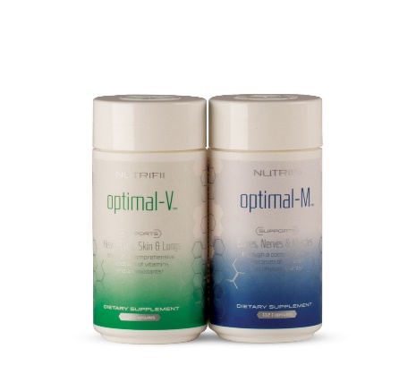

ARIIX announces Optimals supplements to be included in the Physicians’ Desk Reference
By wp-admin
Posted September 11, 2014
In ARIIX News, ARIIX News or Press Releases, Healthy Weight Loss, Press Releases 01
ARIIX announces Optimals supplements to be included in the Physicians’ Desk Reference
Most health professionals in the United States consider the Physicians’ Desk Reference one of the most important and frequently consulted reference books in the industry
BOUNTIFUL, Utah – Premier global health and wellness company ARIIX announced today that Optimals Vitamins and Minerals nutritional supplements will be listed in The Physician’s Desk Reference (PDR), the most widely used compilation of prescribing information used by physicians. Virtually every physician in the United States uses the PDR, with readership studies indicating that nine out of ten doctors consider the PDR their most important and most frequently consulted reference book.
“There are a very limited number of nutritional companies listed in the PDR,” says Dr. Ray Strand, MD. “The Physician Desk Reference (PDR) is the physician’s bible. I am excited that I am now able to point out to my patients that ARIIX Optimals are listed and part of the PDR.”
The PDR is an annual directory of ethical pharmaceutical, biological, and diagnostic products published as a service to the medical field. Inclusion in the Physicians’ Desk Reference adds to the visibility and credibility of ARIIX’s already well-regarded reputation for exceptional quality, integrity and standards. In the last year, Optimals have also earned NSF International certification, following verification of the products’ safety and adherence to strict standards of quality through rigorous independent third-party testing.
Information about ARIIX Optimals within the PDR highlights the quality of the ingredients, noting that they are manufactured according to pharmaceutical Good Manufacturing Practices (GMP) standards and meet United States Pharmacopoeia (USP) guidelines. It also includes dosages and instructions for the products’ recommended use.
“From day one we knew that our products needed to pass the highest level of scrutiny and testing to become the clear choice for our customers around the world,” said Mark Wilson, ARIIX President. “That’s why we continually exceed industry standards in manufacturing, third-party testing, and collaboration with recognized experts in nutrition. Our customers expect the very best when they see the ARIIX Seal of Approval for Superior Quality & 100% Potency Guarantee. Being listed in the PDR is one more step in our commitment to supporting their health.”
“The significance of this goes well beyond the walls of a doctor’s office,” adds Deanna Latson, ARIIX Chief Product Officer. “We are pleased that Optimals have been included in the latest version of the PDR because doctors, health care professionals, health-and-fitness leaders, and even smart families have come to rely on this influential publication to keep them aware of the best choices for supporting their health needs.”
The PDR has been relied upon as the authoritative source for prescription drugs for 68 years. Found in virtually every physician’s office, pharmacy, clinic, and library, no medical reference is more current, more recognized, or more respected. The PDR contains full, FDA-approved drug label information, including warnings and precautions, drug interactions, and hundreds of full-color pill images. Every label in the PDR includes information on dosages, side effects, and safety information.
Each year, copies of the PDR are distributed to approximately a half-million practicing physicians and chief pharmacists in the United States. In addition, other health professionals – including dentists, nurses, veterinarians, hospitals, and libraries – purchase the book, raising the total distribution to well over one million copies.

